Bayesian-thinking workshop/group assignment: Density dependence in forests
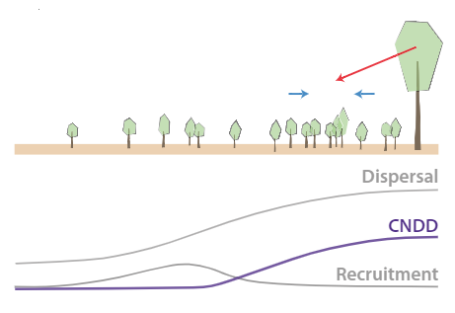
Background: The Janzen-Connell hypothesis provides an explanation for the large diversity of tree species in forests. A key component of this hypothesis is that tree species may attract/accumulate species-specific enemies during their lifetime, reducing the fitness of their offspring within the local environment, and thereby controlling/maintaining the species’ abundance. This latter mechanism is commonly referred to as Conspecific Negative Density Dependence (CNDD, e.g. Hülsmann et al. 2021, Fig 1). Mathematical models suggest that when CNDD is relatively strong compared to density-dependent effects exerted by other species (Heterospecific Density Dependence, HNDD), it indeed can promote the coexistence of many tree species within a community (e.g. Eppinga et al. 2018).
Given the size and lifespan of trees, measuring CNDD and HNDD experimentally is challenging. Hence, previous studies have aimed to infer these strengths from observational data of adult trees and seedlings from forest inventory surveys (e.g. LaManna et al. 2017a,b). Providing the appropriate analysis framework for this type of data is challenging, as both variables (i.e. adult density and seedling density) are error-prone proxies (Dickie et al. 2012; Detto et al. 2019), which may lead to a regression dilution effect that interacts with the abundance of tree species investigated, for example (Hülsmann and Hartig 2018; Hülsmann et al. 2021). The idea of this project is to develop a Bayesian analysis framework to study in more detail how error-prone proxies may propagate into the uncertainty of model estimates, and/or to provide a framework that integrates these observations with information known from pot experiments with tree seedlings. Hence, the project would aim to identify to what extent forest inventory-type (and experimental) data is (are) able to constrain important parameters describing density dependence of tree species. Below, an empirical dataset to do so is described, but this dataset may be further complemented with simulated data.

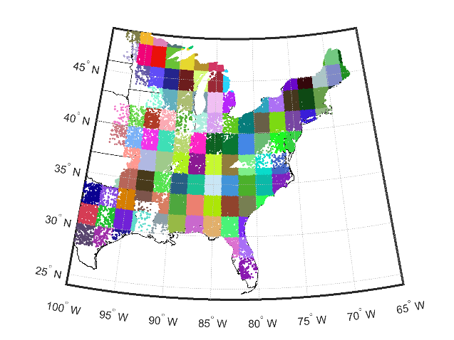
Available dataset we could work with: We can use the dataset extracted by Johnson et al. (2012) and further analyzed in Eppinga et al. (2018), of the US Forest Service’s Forest Inventory and Analysis (FIA) census from 2009. All plots east of the 100th meridian were selected (~200,000 plots, with ~7m radius). At ~ 60,000 locations, 2-4 plots (referred to as subplots) were measured. In total, the plots contain ~ 1,000,000 observations, where an observation could be: i) the number of adults of a tree species in the plot and their cumulative basal area; ii) the number of tree seedlings of a particular tree species, as observed in a ~ 2m radius microplot. The previous studies quantified strengths of conspecific and heterospecific density dependence of all tree species for each grid cell in which they were observed ≥ 30 times.
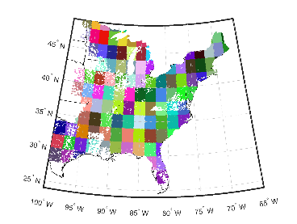
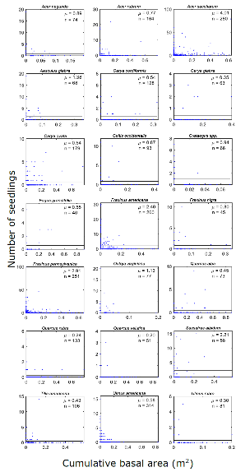
Previous approach: The previous studies used a standard regression approach (exponential fit with negative binomial error distribution), using adult species density (either # adults in plot or cumulative basal area in plot) as independent variable and seedling density (# individuals in the subplot) as the dependent variable. Conspecific effects were determined using seedling data and adult data from the same species; only an average heterospecific effect was calculated, i.e. summing the adult data of all competitor tree species to create one aggregate independent variable. The slope parameter was then used as a measure of density dependence, with negative slopes indicating negative density dependence, and positive slopes indicating positive density dependence.
Ideas on how to proceed, with the group assignment: As noted above, a Bayesian framework may provide a more explicit consideration of the limitations inherent to the observational type of dataset used, but also may allow for utilizing knowledge obtained independently from pot experiments. The project could be developed into multiple directions, according to the group’s interests. Examples of potential directions could be (but are certainly not limited to):
- Use a hierarchical modelling approach (e.g. Schliep et al. 2017), where subplots are used as location replicates to estimate observation error in adult densities.
- Use a hierarchical modelling approach, where climatic variables are directly included as co-variates (rather than separate fitting for 2 by 2 degree grid cells).
- Use recent experimental studies of density dependence of tree species to inform priors for the density dependence parameters. Priors could be species-specific is information is available (Bennett et al. 2017), or based more generally on mycorrhizal association (Steidinger et al. 2019)
- Compare the empirical dataset with simulated datasets with known strengths of density dependence to infer the explanatory power of the data.

References:

Bennett, J.A., Maherali, H., Reinhart, K.O., Lekberg, Y., Hart, M.M., Klironomis, J. Plant-soil feedbacks and mycorrhizal type influence temperature forest population dynamics. Science 355: 181-184. LINK.

Chisholm, R.A., Fung, T. 2018. Comment on: Plant diversity increases with the strength of negative density dependence at the global scale. Science 360: eaar4685. LINK.

Detto, M., Visser, M.D., Wright, S.J., Pacala, S.W. 2019. Bias in the detection of negative density dependence. Ecology Letters 22: 1923-1939. LINK.

Dickie, I.A., Hurst, J.M., Bellingham, P.J. 2012. Comment on: Conspecific negative density dependence and forest diversity. Science 338: 469. LINK.

Eppinga, M.B., Baudena, M., Johnson, D.J., Jiang, J., Mack, K.M.L., Strand, A.E., Bever, J.D. 2018. Frequency-dependent feedback constrains plant community coexistence. Nature Ecology and Evolution 2: 1403-1407. LINK.

Johnson, D.J., Beaulieu, W., Bever, J.D., Clay, K. 2012. Conspecific negative density dependence and forest diversity. Science 336: 904-907. LINK.

Hülsmann, L., Chisholm, R.A., Hartig, F. 2021. Is variation in conspecific negative density dependence driving tree diversity patterns at large scales? Trends in Ecology and Evolution 36: 151-163. LINK.

Hülsmann, L., Hartig, F. 2018. Comment on: Plant diversity increases with the strength of negative density dependence at the global scale. Science 360: eaar2435. LINK.

LaManna, J.A., Belote, R.T., Burkle, L.A., Catano, C.P., Myers, J.A. 2017. Negative density dependence mediates biodiversity-productivity relationships across scales. Nature Ecology and Evolution 1: 1107-1115. LINK.

LaManna, J., Mangan, S.A., Alonso, A. et al. 2017. Plant diversity increases with the strength of negative density dependence at the global scale. Science 356: 1389-1392. LINK.

Schliep, E.M., Gelfand, A.E., Clark, J.S., Tomasek, B.J. 2017. Biomass prediction using a density-dependent diameter distribution model. The Annals of Applied Statistics 11: 340-361. LINK.

Steidinger et al. 2019. Climatic controls of decomposition drive the global biogeography of forest-tree symbioses. Nature 569: 404-408. LINK.

